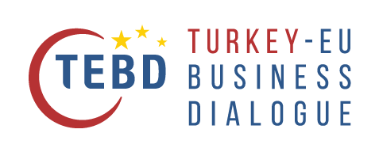

This project is co-funded by the European Union and the Republic of Turkey



|  |  |
| --- | --- |
| 1. Name of your Chamber | Click or tap here to enter text. |
| 2. Contact person | Mr/Mrs Click or tap here to enter text.  Email: Click or tap here to enter text.  Phone: Click or tap here to enter text. |
| 3. Interest of the Chamber  *Please tick which areas are of interest to your Chamber, according to the description of activities presented above (multiple ticks possible).*  *This list allows the TEBD team to reach out to interested Chambers with more specific information in due time, when a specific activity is prepared.* | **Business Dialogue**: Chamber speaker or member follow up group  **Business Dialogue**: Company (member) speaker  **Company Survey**: Organising the survey in EU and/or in Turkey  **SME workshop** **in Turkey**: Expert/Speaker  Fields of Expertise: …………………………………………………………………..  **SME workshop in the EU**: host Chamber  Sectors of interest: …………………………………………………………………..  Expert for the **Energy Efficiency Audit**  Expert for the **Solvency Audit**  **Academy** : Course Leader  Fields of Expertise: …………………………………………………………………..  **Academy** : Participant  Participant to a **Study Visit to Turkey**  Local co-organizer for a **Study Visit in the EU** |
| JUSTIFICATION (please describe your motivation/interest to join one or more of the above activities) | |

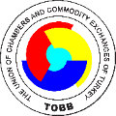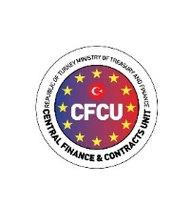Application form to be sent to Ángela Ustárroz ([ustarroz@eurochambres.eu](mailto:ustarroz@eurochambres.eu))

More information:

[www.tebd.eu](http://www.tebd.eu) or [ustarroz@eurochambres.eu](mailto:ustarroz@eurochambres.eu) – Tel. +32 2 282 08 79